**GEOGRAPHIC INFORMATION SYSTEMS 2 – SCIENTIFIC DATA**

**UMEÅ UNIVERSITY – DEPARTMENT OF ECOLOGY & ENVIRONMENTAL SCIENCE**

**LAB1 – ASSIGNMENT 1**

**LAB1.1 Reading Comprehension**

**LAB1.2 Lab1 questions**

**LAB1.3 Map assignment**

**LAB1.4 Map questions**

**LAB1.1 – READING COMPREHENSION**

**LAB1.1.1**

**Referencing Li & Wu (2004), describe two ways in which to achieve the goal of landscape pattern analysis (establishing relationships between pattern and process) without being overwhelmed by data and analyses available through GIS.**

In order to talk about how to achieve the goal of landscape pattern analysis, this goal should be probably described first. According to Li & Wu (2004), “*The* ***ultimate goal*** *of landscape pattern analysis should be* ***to achieve better explanations and predictions of ecological phenomena*** *based on established relationships between pattern and process.*”

When it comes to efficiently achieve this goal, researchers can be, in many occasions, overwhelmed by “*numerous indices, spatial statistical methods, and big volumes of GIS and remote sensing data*” (Li & Wu, 2004, p397-398)1, especially without sufficient understanding of mechanisms to extract and interpret values from these data.

There are “two critical questions” (Li & Wu, 2004, p398)1 that should be raised and that can be used to achieve this goal by establishing relationships between spatial pattern and ecological process:

1. “*How to use knowledge about spatial heterogeneity to improve explanations and predictions of ecological systems*” (Li & Wu, 2004, p398)1.

Knowledge about the whole process of landscape analysis should be gained in advance. According to Li & Wu (2004), only by previously discovering and describing patterns, and by understanding “*the determinants of pattern, and the mechanisms that generate and maintain those patterns*” (Levin, 1992)2, better explanations and predictions of ecological systems can be undertaken, which are in the end the final goal of landscape pattern analysis.

1. “*How to scale up models and/or relationships across scales with aid of quantifying spatial heterogeneity at multiple scales*” (Li & Wu, 2004, p398)1.

Scales of observation and analysis must obviously match each other (Li & Wu, 2004, p392)1. According to Wu (1999)3, “*if the pattern and the process do not operate at similar rates and in the same domains of spatial scales, they cannot have an interactive relationship*” (Li & Wu, 2004, p391)1.

Different scales should be used to undertake the landscape pattern analysis, in order “*to adequately quantify the spatial heterogeneity and detect characteristic scales of landscapes*” (Li & Wu, 2004, p392)1. This means that observation should be also made at different scales.

Thus, given that the observation scale is inherent to the data set collected, it is only the analysis scale that can be changed and “*superimposed to the data*” (Li & Wu, 2004, p392)1. Otherwise, by manipulating data (e.g. scaling), instead of “*observing the landscape directly with two or more sensors (or sampling schemes) of different resolutions*”, “*if the surrogate fundamentally differs from the direct observation, the rescaling results represent artifacts of data manipulations and may not be used to infer trends from the scale of observation*” (Li & Wu, 2004, p392)1.

**LAB1.1.2**

**Describe two ways in which remotely sensed elevation data (i.e., digital elevation models) can be used in** **geomorphological research, as described by Smith & Pain (2009).**

According to its definition, “*Geomorphology is that part of physical geography that deals with the form of the Earth’s land surface and the processes that act upon it.*” (Smith & Pain, 2009, p568). Also as per Smith & Pain (2009), “***Geomorphologists are*** *therefore* ***concerned with the******morphology*** *(i.e., shape)* ***and******composition of the land surface*** *and use this information to determine presently operating processes, as well as postdicting prior landforms (and the events that formed them) and attempting to predict future land surface change (and events)*”.

The variety of remote sensing technologies, which produce DEMs of different qualities and spatial resolution, and the chance to manipulate, model, and combine these DEMs with other images (Smith & Pain, 2009, p565), provide a significantly wide range of applications within geomorphological research. Two of these applications are described below:

1. The study of surface elevation (Smith & Pain, 2009, p575-576). The chance to easily **obtain 3D image models** from remotely sensed elevation data is probably its most obvious application.

As per Smith & Pain (2009), “*either solely or in combination with image data, allow 3D image models to be produced, providing more powerful interpretation and visualization tools*”. E.g., by combining DEMs with images obtained from different satellites, accurate studies of alpine landforms can be produced. Much more sophisticated applications of DEMs can be applied to geomorphology and other disciplines when “*Quantitative analyses take advantage of the calculation of geomorphometric parameters from elevation*”, which Smith & Pain (2009) describe in their paper.

1. The study of surface reflectance (Smith & Pain, 2009, p577). By using the combination of DEMs, which provide landform properties, and spectral reflectance, which provide soil characteristics, land **erosion processes can be assessed**, such as the assessment of erosion processes in the tablelands of New South Wales, and the Todd River area of central Australia, by Pickup and Marks (2000 and 2001)6, (Smith & Pain, 2009, p577).

Also by using radiometrics and DEMs, movement of materials in river courses can be studied, such as the study movement of materials in streams in England and Germany by Lahti and Jones (2003)7.

**REFERENCES**

1. Li, Harbin, and Jianguo Wu. “Use and Misuse of Landscape Indices.” Landscape Ecology, vol. 19, no. 4, 2004, pp. 389–399., doi:10.1023/b:land.0000030441.15628.d6.
2. Levin S.A. 1992. The problem of pattern and scale in ecology. Ecology 73: 1943–1967.
3. Wu J. 1999. Hierarchy and scaling: Extrapolating information along a scaling ladder. Canadian Journal of Remote Sensing 25: 367–380.
4. Smith, M.j., and C.f. Pain. “Applications of Remote Sensing in Geomorphology.” Progress in Physical Geography, vol. 33, no. 4, 2009, pp. 568–582., doi:10.1177/0309133309346648.
5. Clark, R.N. 1999: Spectroscopy of rocks and minerals, and principles of spectroscopy. In Rencz, A.N., editor, Manual of remote sensing, volume 3, Remote sensing for the Earth sciences, New York: Wiley, 3–58.
6. Waldhoff, G., Bubenzer, O., Bolten, A., Koppe, W. and Bareth, G. 2008: Spectral analysis of ASTER, Hyperion, and Quickbird data for geomorphological and geological research in Egypt (Dakhla Oasis, Western Desert). International Archives of the Photogrammetry, Remote Sensing and Spatial Information Sciences 37, 1201–206.
7. Lahti, M. and Jones, D.G. 2003: Environmental applications of airborne radiometric surveys. First Break 21, 35–41.

**LAB1.2.1 Lab1 Q1 – Metadata: Table of files**

**Create a table of your files used and created in this lab. Make sure your table contains five columns: (1) name of file, (2) projection/coordinate system, (3) description of data in the file, (4) source (course folder, where it was downloaded from, or the file(s) that you manipulated to form the new file), & (5) tool/method used to create the file.**

A preview of the created excel schedule, including received and newly created filed, can be seen hereunder. The full excel file has been also included in the submission in the Drop Box.

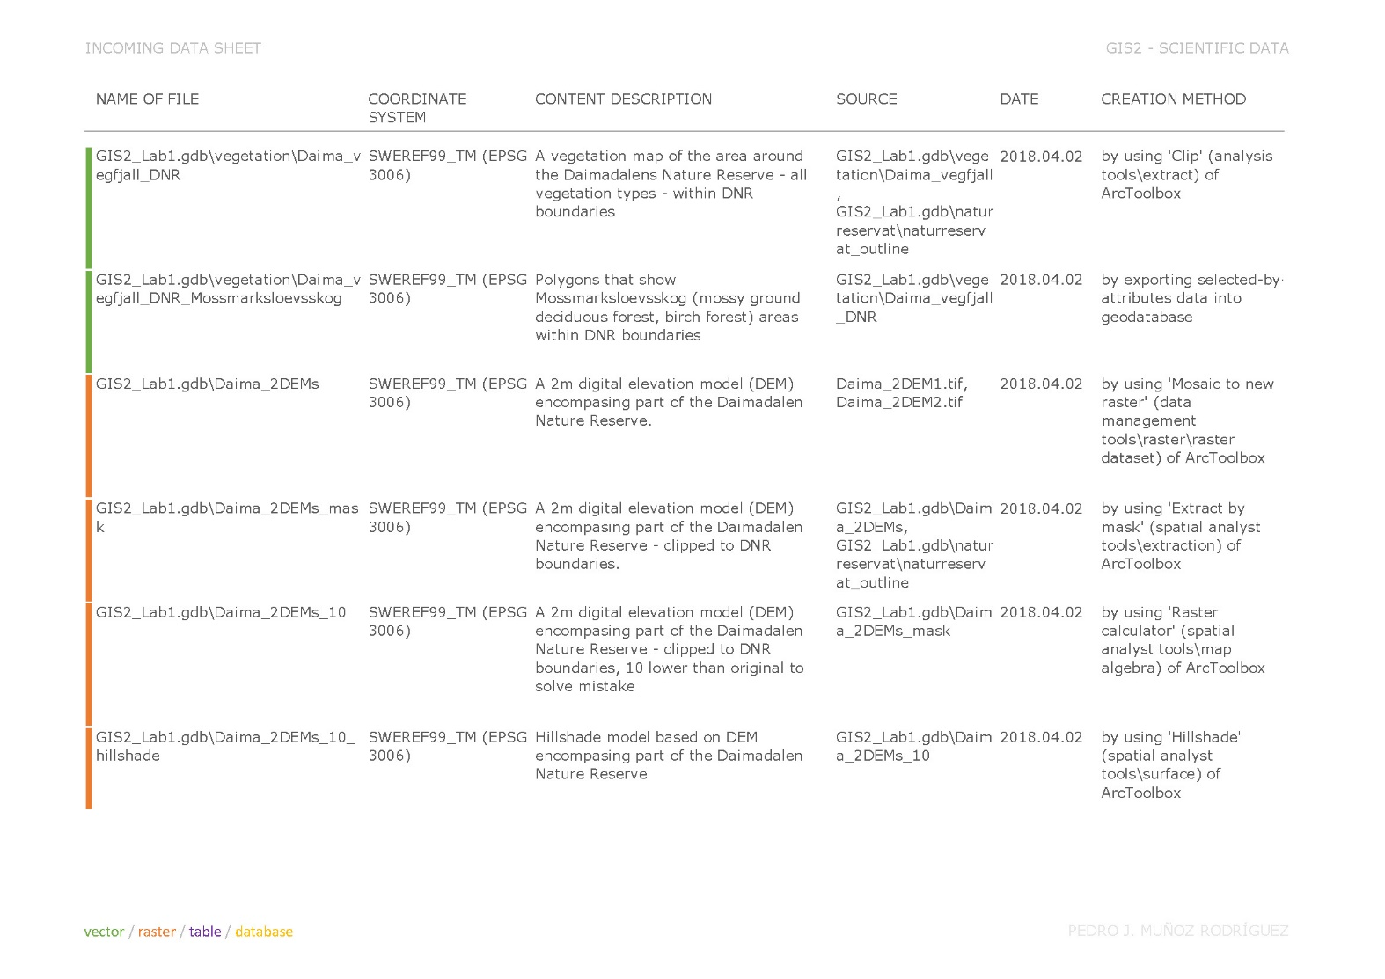

**LAB1.2.2 Lab1 Q2 – Check your DEM—Mosaic, extract & map algebra!**

**Let’s check your math! Use the identify tool to determine the elevation of a precise cell: Look at the General map and find the mountain ‘Sjeltietjahke’ on the southern border of the DNR. Zoom far into the point that shows the top of the mountain (to the left of the height according to the General Map: 1085 m).**

**a. According to the DEM, what is the elevation right under the point?**

An elevation of 1072 m has been obtained by using the identify tool on this grid (Daima_2DEMs_10.tif).

**b. According to DEM, is the highest elevation on that mountain where the general map shows?**

A contours shapefile with contours every 1 m has been created, in order to check the elevations around this point.

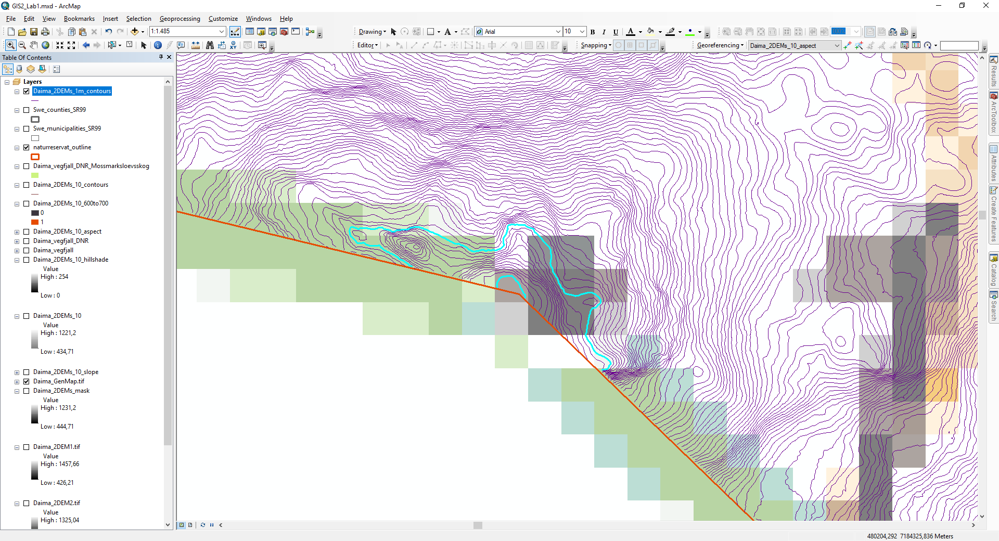

The previously obtained elevation of 1072 m at this point can be easily double-checked by selecting the contour that runs through the point. Having a further look at this contours map, it can be also checked that this point is not the highest elevation in this area.

**c. If not, in which direction and how far away is the true highest point (according to the DEM) and what is the highest elevation of Sjeltietjahke?**

By looking at the selected contours in the attributes table, it can be checked that the highest contour in this area is located at an elevation of 1084 m. By checking the elevation of points above this contour (on the grid), elevations of approx. 1084,63 m can be observed, which are only slightly different from the 1085 m elevation shown on the general map at this point.

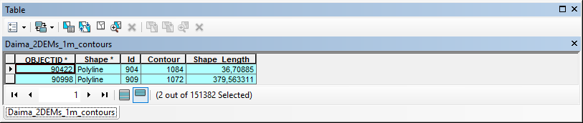

After observing on the map that the highest point of the DEM is located in the west direction from the highest point on the general map, a distance of approx. 40 m between both points can be measured.

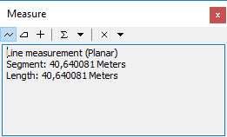

**LAB1.3 – MAP ASSIGNMENT**

**LAB1.3.1 MAP 1** – Easy-to-read map for a mushroom-picking weekend pamphlet

This map shows, in the form of a weekend-activity pamphlet, the areas within Daimadalen Nature Reserve that meet the requirements of vegetation type, elevation, steepness, and south facing, which have been assumed as optimal for chanterelle-picking.

**LAB1.3.2 MAP 2** – Thematic maps for a report figure

This layout contains a series of four maps, where conditions required as optimal for chanterelle location, such as vegetation type, elevation, steepness, and south facing, are separately shown.

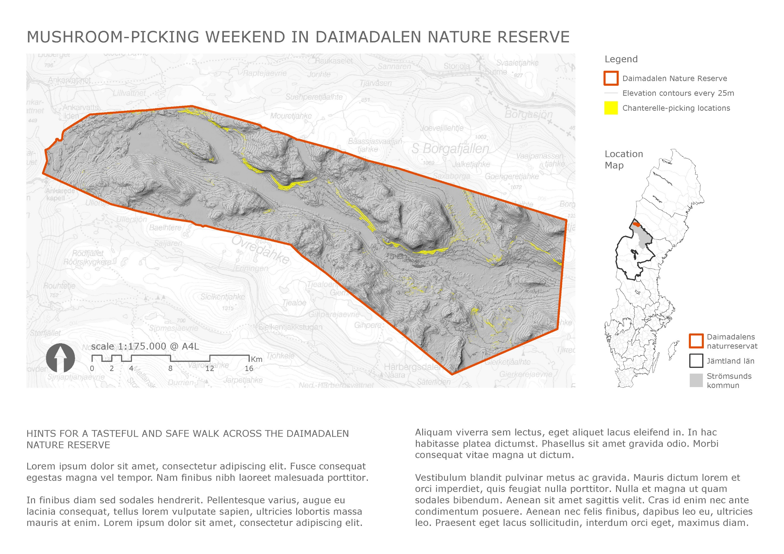

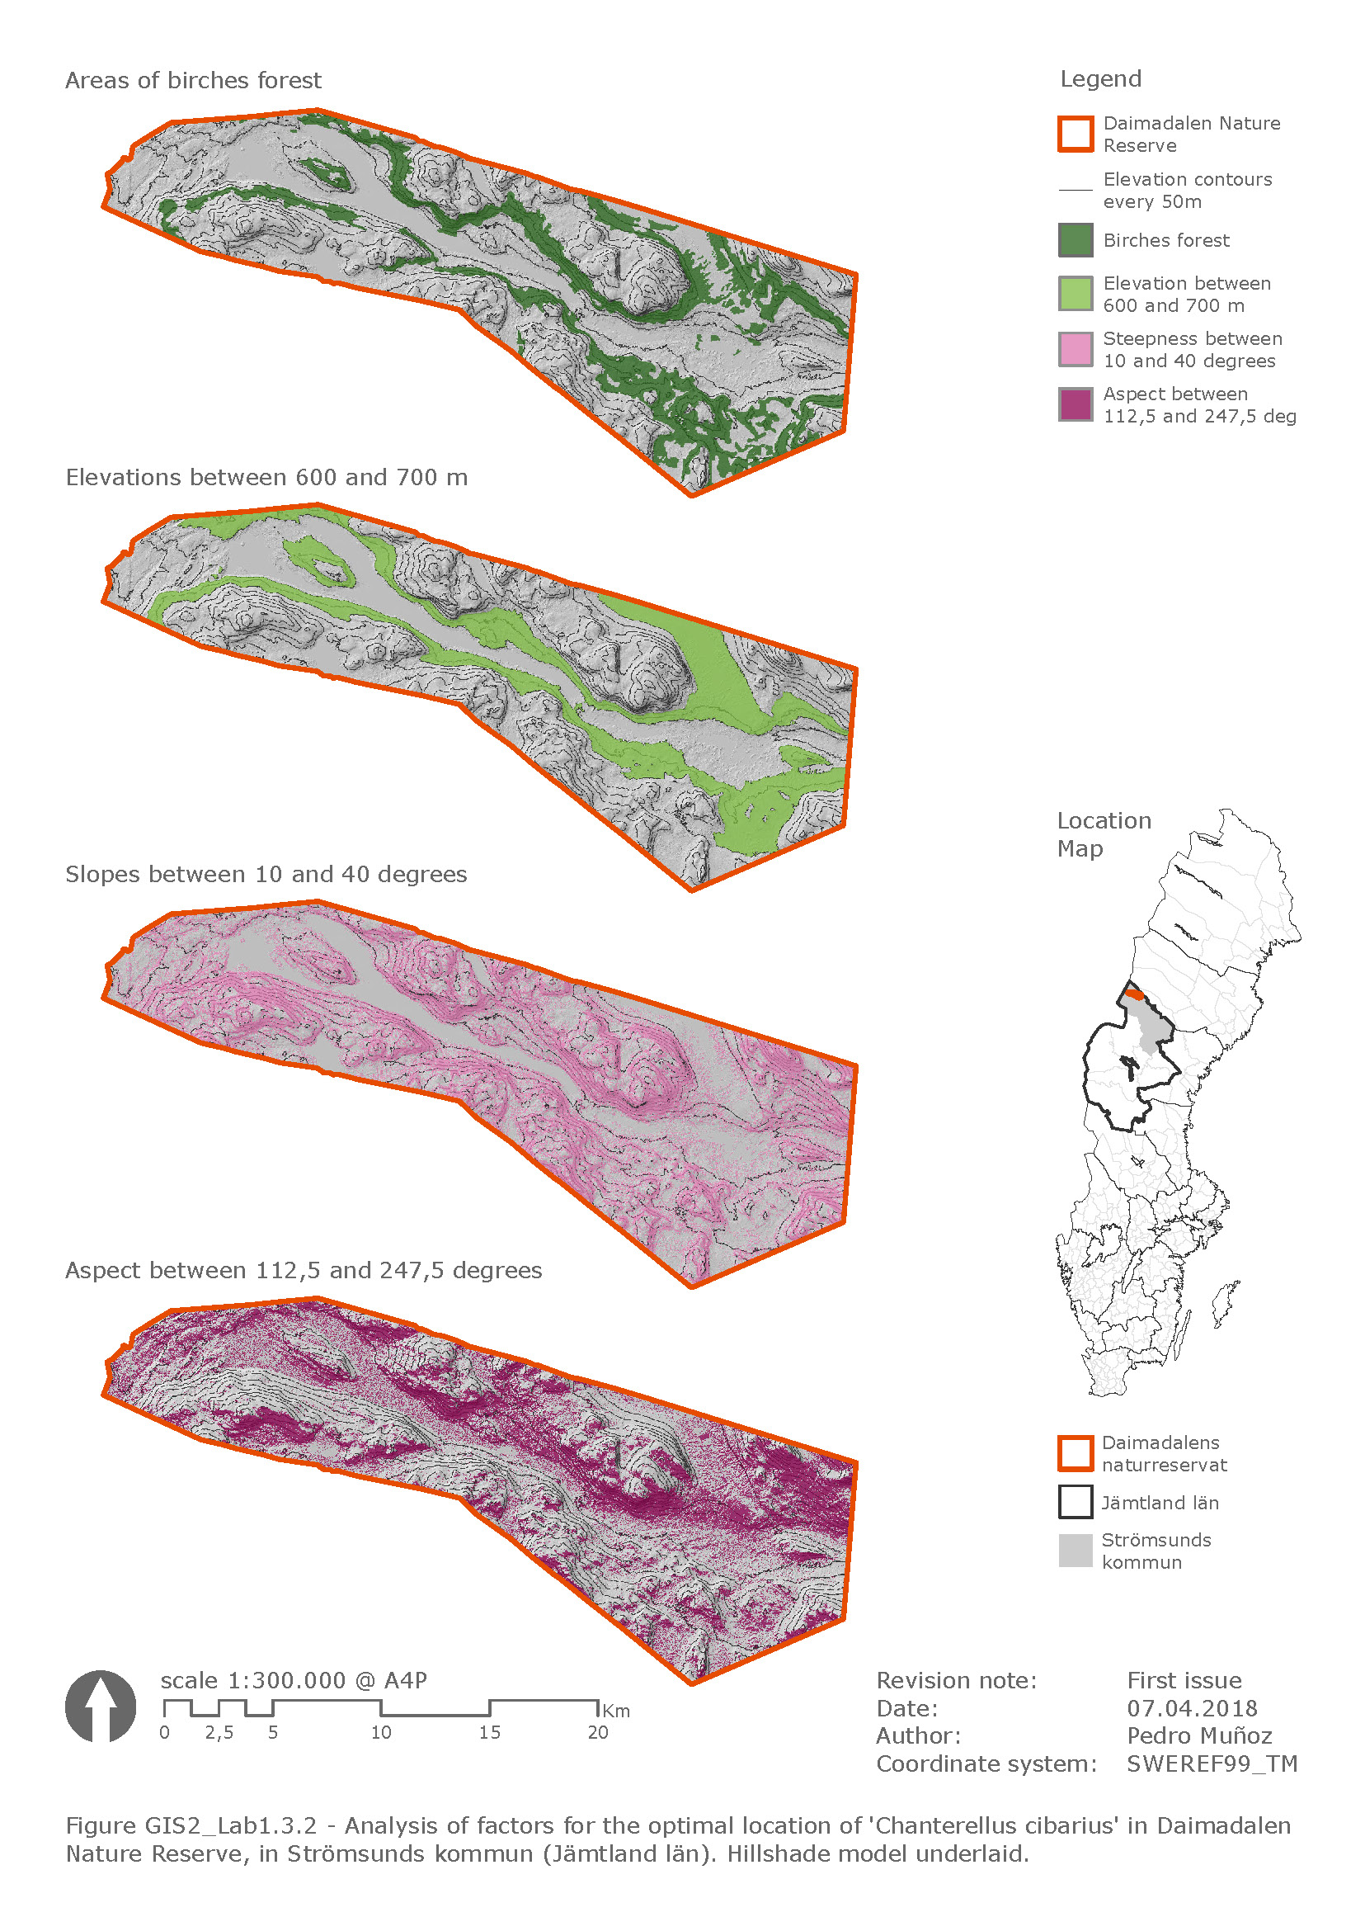

**LAB1.4 – MAP QUESTIONS**

**LAB1.4.1**

**Map layout explanation: Explain how your map layout effectively communicates the purpose of your map based on the 6 Cs. Go through each ‘C’ and explain why you made the choices you made in, for example, colour and layout.**

Given that layouts Lab1.3.1 and Lab1.3.2 have different purposes, they have been therefore designed following different criteria. However, both of them have been conceived as with a grey-scale base map, to which relevant data layer have been overlaid using bright and saturated colours. The contrast produced by this overlay helps focusing on the relevant information of the map.

The following criteria have been applied to layout Lab1.3.1:

* A4 landscape **format** has been used in order to optimise the map size.
* Because it is a pamphlet format, its purpose should be to show the **relevant information** in a simple and effective way, as well as probably to show certain further information in the form of text (descriptions, hints, advice, and so on). All other information, such as revision notes, author, coordinates system, have been omitted, since these are probably not of interest in this case.
* A black and white **hillshade model**, which has been obtained from a DEM, has been used as a map base, which had been previously clipped to the boundary of Daimadalen Nature Reserve.
* Additionally, because all data has been analysed within this boundary, a high transparent **general map** has been underlaid in order to give a certain sense of context to the data within the boundary.
* Especial attention had to be paid to **how layers of contours and chanterelle-picking locations are overlaid**, so that these were efficient and effective, e.g., by applying transparency to the chanterelle-picking locations layer, or by varying to white the colour of the contours layer. It has been observed that, although transparency of analysis results layers reveals the topography below, their contrast effect over the grey-scaled layers was reduced, which was not ideal. Neither was it when contours colour was switched to white, because it reduces its effectiveness to show steeper areas. As a solution, analysis result layer has been shown at 0% transparency, and contours have been overlaid to it. Although analysis results layer masks the DEM image below, the contours overlaid gives back the topographical information lost.

The following criteria have been applied to layout Lab1.3.2:

* A4 portrait **format** has been used in this case, in order to optimise the size of the four maps to include.
* Because it is a report figure format, its purpose is to show detailed information and therefore, some **technical information** such as revision notes, author, and coordinate system, have been included in the layout.
* A **caption** has been added as well, to show the content of the figure.
* A black and white **hillshade model**, which has been obtained from a DEM, has been used as a map base, which had been previously clipped to the boundary of Daimadalen Nature Reserve.
* In this case, because of its character of diagrammatic maps, **no context** has been shown around the boundary.
* Due to its scale, **elevation contours every 50 m** are shown in this case (instead of every 25 m), in order to avoid cluttering the map in certain steep areas.
* Similar criteria to layout Lab1.3.1 has been used, when it comes to **overlay and transparency** of analysis results layers and contours layers.
* Regarding to the **colour palette** used, colour-blind friendly criteria have been used to analysis result layers. The diverging colour palette ‘9-class PiYG’ from <http://colorbrewer2.org> has been used, in order to select only the four most saturated colours from it, to apply them to our four maps.

**LAB1.4.2**

**Which of the four requirements for ideal chanterelle-picking locations are most likely to be most limiting in finding an ideal location?**

When it comes to the most restrictive requirement, the aim would be to look for the one with the smallest suitable area. It is not so straight-forward as it could look like though, given that one of the requirements is shown in a vector layer:

* ‘Daima_vegfjall_DNR_Mossmarksloevsskog’ (in which the geometry of suitable areas could be calculated in a new field)

and the other three of the files are shown in grids:

* ‘Daima_2DEMs_10_600to700’
* ‘Daima_2DEMs_10_slope_10to40’
* ‘Daima_2DEMs_10_aspect_112to247’ (in which pixels of suitable areas could be counted and compared with one another)

Among the various possibilities, such as converting the vector file into a raster file, so that its suitable pixels can be compared, or converting the other three vector files into rasters, so their (geometries) areas could be observed, the following solution has been applied:

The vector layer ‘Daima_vegfjall_DNR_Mossmarksloevsskog’ has been converted into a raster layer, with the same size of cell as the other three layers (2, 2 m), so that the number of pixels of suitable areas can be compared.

By observing the attributes table of each grid, the following details can be extracted:

* 14536611 pixels of ‘Daima_vegfjall_DNR_Mossmarksloevsskog’ meet the requirements of location within a birches forest area.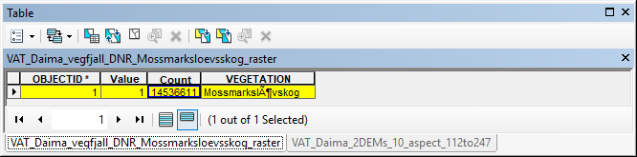
* 17834695 pixels of ‘Daima_2DEMs_10_600to700’ meet the elevation requirements.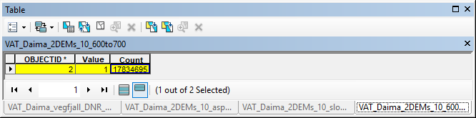
* 30072674 pixels of ‘Daima_2DEMs_10_slope_10to40’ meet the steepness requirements.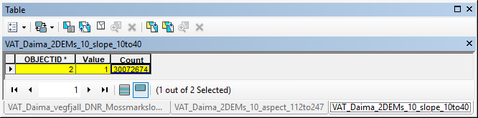
* 25313693 pixels of ‘Daima_2DEMs_10_slope_10to40’ meet the south-facing requirements.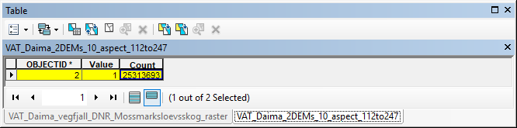

This means that **birches forest areas** are the most restrictive of all four requirements to find an ideal for chanterelle-picking.